UK BMX National Series – Gosport

For rounds X and X of the HSBC national series the team travelled south to Gosport. There hadn’t been a national at Gosport for 5 years, some of the team hadn’t even started racing the last time a national was held there and Harry Kirby did his first ever national in 6 and under.

The track had been re-built this year by French track builders Pro Tracks, the builders of Baku Worlds track and Zolder, next year’s Worlds track. It was nothing like the previous one, it had been returned to a more standard 4 straight inside/outside U shape and it’s much wider than the 6 or 7 straight marathon that stood there before. The track didn’t have a massive 5 metre monster start hill, it had a more standard height hill with a Pro Gate and a Nic Nak Engineering barrel. The gate and pad had probably the best grip of any gate in the country, it didn’t slip at all, your front tyre gripped perfectly, and you had no wheel spin at all, regardless of how bad the conditions got.

The first and second straight are similar in many ways to Telford, from the gate there’s a big mellow double, suited to a pump or manual, then a big triple into the first berm. The first berm itself is huge, reminiscent of Manchester Indoor’s first berm, giving ample opportunity for moves and it can accommodate multiple exit lines as the track splits into two for the second straight. Like Telford, the jump out of the berm is a low roller double shared by the pro and challenge straight; then the pro goes off to the right and is a huge step up with a normal lippy double on the left for everyone else, the final jump on the straight is a step up you can jump onto like the last jump on the Cyclopark first straight. The second berm has a big exit and is very steep, which is good, because you must carve a tight line to stop people cutting across the back of the pro straight landing and getting under you. The third straight starts off with an easy step up, but there’s a roller almost at the bottom of the landing, so most prefer the manual, because it’s really easy to over jump and go over the bars, something that was happening to riders all weekend, then a series of deep rollers, before a table, then finally a step up to step down into the last steep and sharp berm. The final straight has an awkward table right out of the corner, it’s pretty steep and kicky, but short, so very easy to over jump, most older riders either pick up for it, or tap manual it. Luckily the rest of the straight is a traditional rhythm, albeit a deep one, with a short sprint to the line.

The Twisted Towers team gazebo set up was in a great spot as ever, this time we were on the top of the final berm, giving us a superb view of the track from on high. We had the usual spacious 3 gazebo set up, which was handy because the weather predicted for the weekend would mean there would be lot of us in there all day. Some of the team had a chance to race the new track in the build up to the national, some of the South Region racers had taken part in a regional there a couple of weeks previous and a few of our Midland crew took park in a club race there the week before, so the track wasn’t a complete unknown quantity to at least some of us. The regional and club race held prior to the national were both wet and windy affairs and there was a very changeable forecast for the national too, so the wet and windy experience could be invaluable.

Friday night practice was a cold and windy affair with drizzle, most of the team took part, some of us stayed on for the open practice, but only did a few extra laps before throwing in the towel, the risk of injury and crashing was increasing, and we’d got what we needed from the session. Saturday was a much nicer day with the weather and the track ran considerably quicker, so there was a lot to be learnt in not very much time, you could realise the potential of the track too, you got to feel how it should be ridden. Sunday was horrendous, horizontal rain for the majority of the day and it was relentless, getting worse and worse as the day went on, so the organisers changed things a bit, making the day shorter with a two-moto transfer system, something very rarely seen in the UK. The meeting was pushed along very effectively, with only a few minutes break for administration between the knockout stages. The track held out superbly, remining hard enough to race and not rutting up at all, with the track team working tirelessly to sweep standing water away as every race went past, a picture posted online shortly after the event finished showed every straight under water and only the jumps showing!

It was the perfect opportunity for us to test out our new goggles too, in all conditions. We’ve just picked up a new eye wear sponsor Flow Vision and we were really happy about that, because we were certainly going to be needing them! With the whole squad running the pioneering disc brake system our bikes would be better suited to downpours than a lot of others, speed control would not be an issue any Twisted rider would have to deal with. The team, as ever gave it their best, we all had a great time and we got some great results along the way too, here’s how it broke down for them individually.

Ben Hallett – Cruiser, age 9-12

This was Ben’s first time at the Gosport track and his initial thoughts were that in places it was like the Telford track and at other parts it reminded him of Redditch. Given that these are 2 tracks that Ben likes, we were hopeful he would do well.

Unfortunately, on Saturday, Ben didn’t make it past the Moto stage, which was very disappointing for him. However, on Sunday, despite the incredibly bad weather conditions, Ben fought a couple of good battles and got into the semi-finals. This was an enormous boost for Ben and he was both nervous and excited about reaching the semi-finals. Ben was happy to make the B final as he has been competing against kids who are considerably bigger, and more powerful.

Ben’s technical skills are improving at every race, he is fast out of the gate and often in the top 3 at the first berm. However, his lack of power means he loses positions as the race progresses. Hopefully as he gets older, and a bit taller, he will start to develop more muscle, which will give him the power he needs.

Reaching the semi-final on Sunday was a great confidence builder for Ben which should help him going forward.

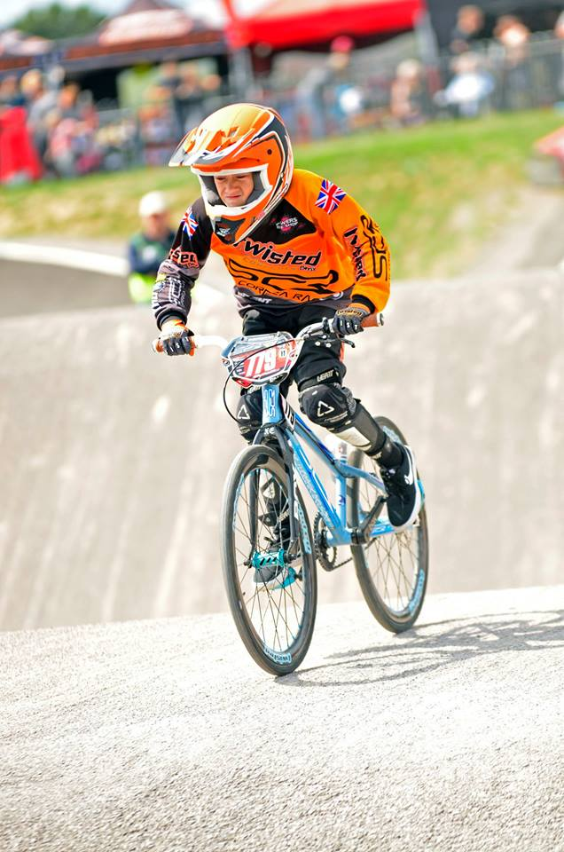

Harry Kirby, Expert Male, age 11

Harry had ridden the track at the regional a couple of weeks before and liked it, he was looking forward to having another go and seeing what he could do at the national. The Saturday didn’t go so well for Harry on the track, his gates just weren’t there, and he was struggling to get on the correct line though the first berm, his third and final straight were fast, it was just the first quarter of the race that was letting him down.

Off the track he was very happy to see his (and Ben’s) buddy Zion Poulter, who had a horrible crash at Telford national and he’d come along to the event to watch after being released from a stay in hospital. Harry even got to push Zion around in his wheelchair and cheer him up, which probably worried Zion’s dad no end.

Sunday was a better day on the track for H, he loves racing in the rain and it showed, his first moto he pulled out a strong mid pack finish, his second moto was a tough one and he pushed the previous day’s finalists to the line and if he’d have got a better gate could have been ahead of some. Harry ended up in a 6-way point tie for the knockout stages and lost out on countback. Harry knows he needs to work hard on his gates over the winter to start making the semi finials next year, so he’s going to start putting the work in now.

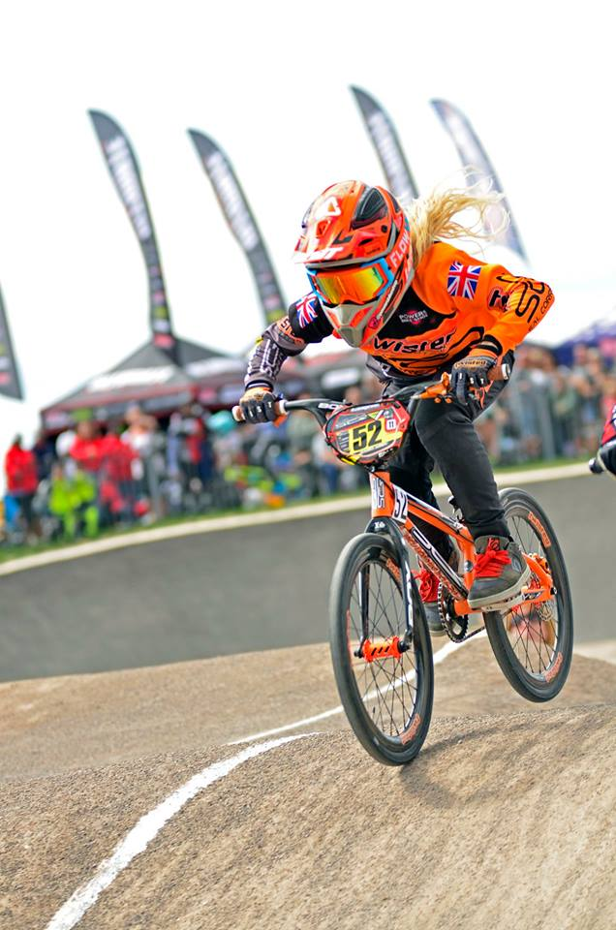

Morgan Haslam, Expert Females, age 14

Morgan had spent a few days at Gosport in the run up to the weekend, so she got to get some practice in before racing. She felt she could ride the track and had fun playing on it, but she said ‘if I’m honest it’s not been one of my favourite tracks this year to race on’.

On Saturday she had a good day, getting a 1st, 2nd & 3rd in her motos, followed by a second in her semi. A good gate from gate 4 gave her a good line into first corner, railing it into 2nd place and managed to hold it round the track.

Sunday was a challenge in the rain and wind, but for some reason Morgan feels she rides well in bad weather and Sunday was no different. She was buzzing to take a clean rack of 1st in her motos and semi, then topped it off with another 2nd place finish in the final. Gosport national has been her best ever weekend for results since she started racing nationals so she’s seriously happy about it!

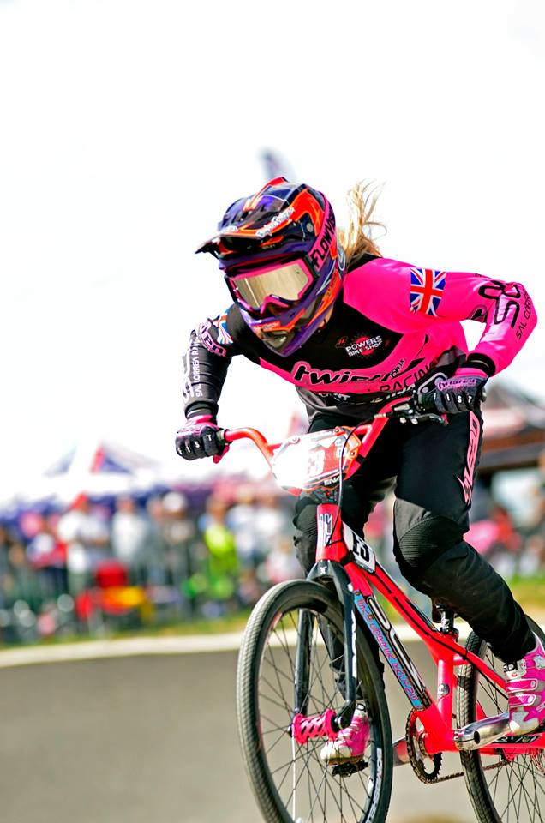

Finn Clark, Expert Male, age 15

‘Let's all go to the south coast for a bit of sunshine, a sneaky break in the New Forest for starters, meant Finn could visit Gosport BMX track for the first time and get some track time’ was the message from Finn’s Dad.

Day 1 started off not the way we would have hoped, the gate dropped and so did Finn, little sharp for the gate’s liking and he hit the deck! Oh dear, it was straight to semis on Saturday, dropping 16, so this was going to be a tough one. Moto 2 couldn't have gone any sweeter, obviously no problems with the gate and 2nd into the first berm, chasing Macca down underneath him into the 2nd and brought it home, happy days, revival back on. A nervous 3rd moto needing a 3rd, but a 4th could still be good enough. Not a great gate and 5th into first berm, he was battling with Jayden for that 4th, or he was out. The final straight was strong and 4th in the bag. The top 16 was on count back, phew, that 1st place did the business.

The Semi was a mixed bag, 5th into the first berm looked promising until a little mistake coming out of the 2nd turn, bonking the front wheel nearly putting him over the handle bars, he lost all the momentum, game over as 4th moved away. Even though Finn tried to make it up it wasn't happening. In the B final Finn was in the mix for most of the race grabbing a 4th.

Day 2, well what can we say that hasn't already been said, WET, reduced to two motos, so the pressure was on to progress to the semis. A great start with a 2nd and sealed it with a strong 3rd in moto 2. Semi time and like day 1 great start in 5th with 4th in touching distance, coming out of the last corner and this was it, lining Matty up for a drag race to the finish. Another oops, a weekend of mistakes, it was not going to be. Bonking and casing, whatever you want to call it, it’s losing momentum, so another B final. This was going to be the highlight of the weekend with the rain absolutely lashing down, as the gate dropped he never looked back, a storming 1st and a great result. So, all in all a mixed bag of results, but also lots of positives.

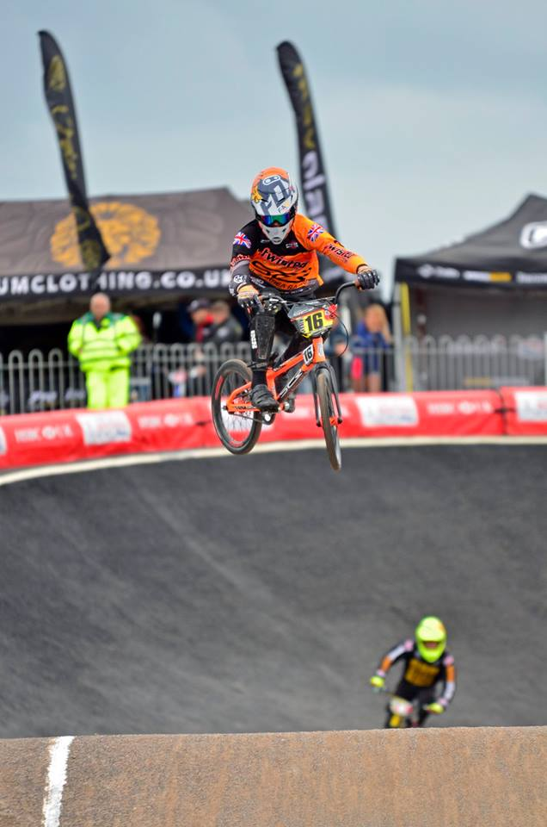

Meeshaq Malone, Expert Male, age 17-24

It was the official team debut for new signing, the super quick and awesomely stylish Meeshaq Malone in the mega tough 17-24 men’s category. Looking back at his weekend our dreadlocked style guru said ‘From racing at Gosport on Saturday and Sunday I felt like riding on the new SCR improves my confidence and my ability on the track. I enjoyed racing but cost myself a semi making a mistake on last straight which ruined my day’. Getting used to a new bike when you first get to ride it at a national is a tough ask as any racer will know, even for a rider as naturally talented as Meeshaq.

On Sunday he felt a lot more confident, and even had the snap in his second Moto, but the bad weather caused him to go off balance, causing him to damage his ribs. He’ll be back and ready for Leicester to show his potential, when he’s properly used to his bike.

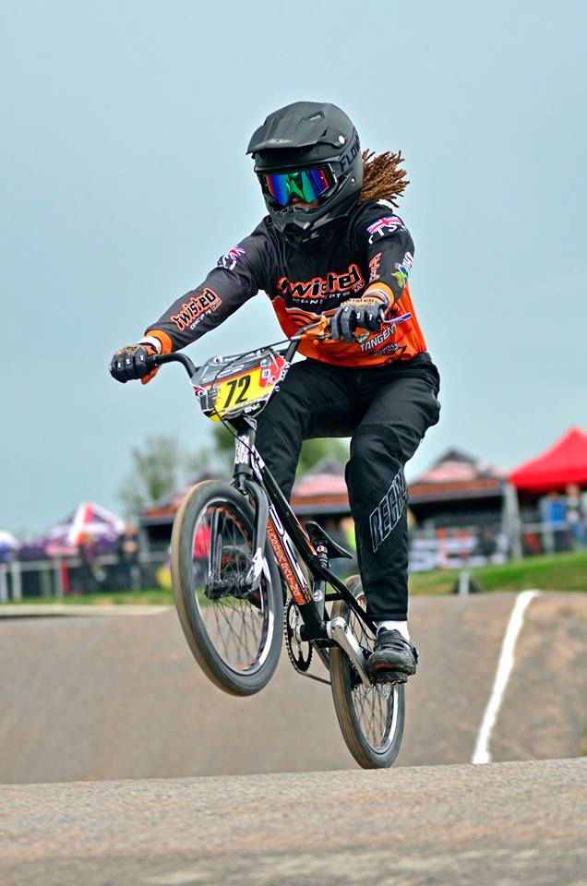

Nathan Konngutong, Expert Male, 17-24

After coming first in his Junior Elite A title in Thailand in July, Nathan was itching to get back to the Nationals here and racing on a decent track again, he said ‘the two tracks I've raced on in Thailand in the last two years were both really rough’.

Unfortunately, Gosport was a bit of a washout in more ways than one for him. He finished fifth in his first two motos on Saturday, then crashed on his third moto. This resulted in yet another hospital visit for Nathan, at the advice of the paramedics he had to be taken to A&E by team premier Paul Hallett. The crash put him out of contention for racing the rest of the day and the whole of Sunday. Fortunately, there was nothing broken, just cuts bruises, and a sore elbow, wrist and belly, but he should be back racing soon, as usual he can’t wait to race his SCR again as soon as possible.

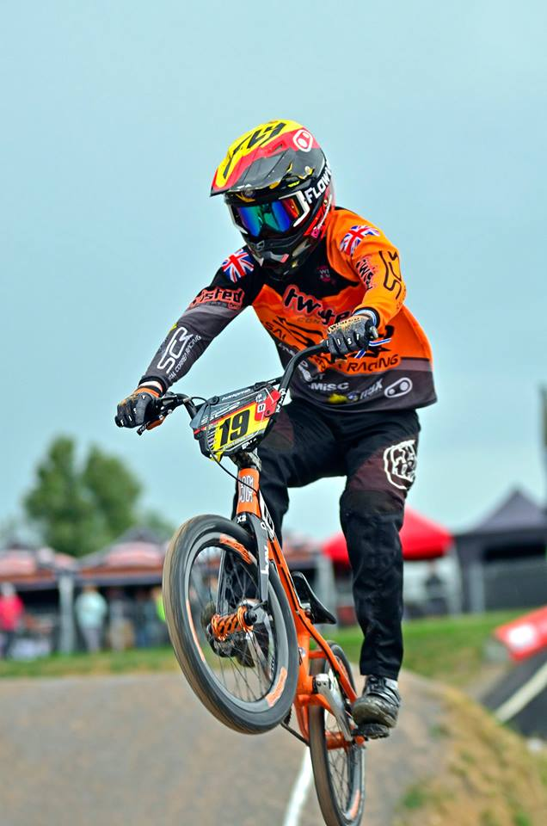

Martin Smiley Brown, Cruiser 17-29

Any national near a beach is set to be a winner in Smiley’s eyes! After the long drive down to Gosport he got there to help with gazebo set up as planned. He thought the track looked amazing, he’d been really wanting to ride it since the videos had started appearing on social media. There was a head wind blowing on the first and third straight, so he thought it looked interesting when practice got underway. He said he couldn't really feel the wind, so it was time to get his head around the track. He thought the Nik-Nak gate was truly amazing.

Saturday was a tough one in the cruisers, 30-39 were merged with his class 17-29, as they only had a few riders, but there were some very quick ones at that. Saturday saw Smiley get 3rd, 3rd, and 5th in the motos, then the dreaded 5th spot in the most stacked semi he’d ever been in. Smiley was disappointed to get 7th in the B final, his worst result of the season so far.

Sunday, Smiley woke up feeling fresh, but the weather was wet and set to get far worse as the day went on, and also forecast to get very windy, and boy did that happen. Luckily, he had his Flow Vision goggles keeping his vision clear. Listening to people moaning about lack of brakes etc. due to the rain made him feel so confident on his custom SCR with a disc brake! Cut down to two moto transfer he had a 3rd and a 1st, great results. He then got though the semi-final with a 4th and onto the A final with a 7th, a much more satisfying result then the previous day.

It was time to get packed up and well out of there for some beach fishing in the pouring rain with his son Harry, what a nutter! Smiley has a few weeks off now till the Brits where he has the honour of rocking the 1.1 plate. And another track near a beach, he can’t wait!

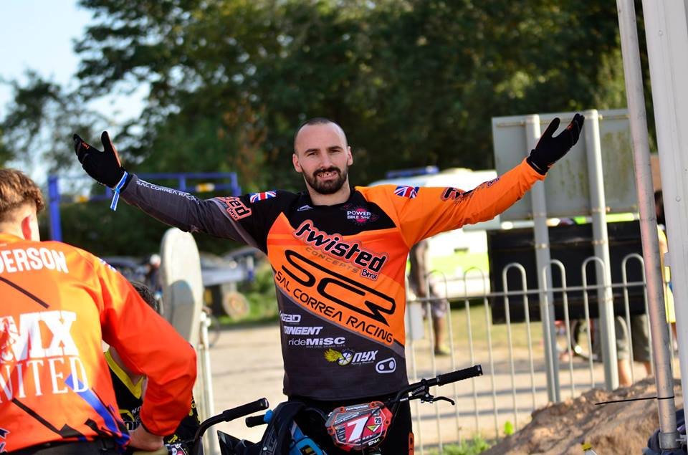

Tonn Haydon, Expert Male, 25-29

Our backpacking Australian team mate was back for more UK BMX action after having such a great time at Telford national. Since then he’s been riding tracks all over England, then he crossed over to The Emerald Isle and took part in an Irish national. He couldn’t resist one more go at a British national before continuing on his European adventures. He said he really enjoyed the new Gosport track. In his considerable experience of riding and racing tracks all over the planet he thinks corners in England are shaped so much better than anywhere else in world. The racing went pretty well for him in the kind of weather he isn’t really used to and we’re not sure he really likes!

Tonn was racing in the combined 25-29 and Masters class, which is a pretty tough group. He got the job done and made the main on both days, getting a 7th on Saturday and a 6th on Sunday, having some superb mid pack battles along the way. He had to admit though that he spent most of Sunday wishing he got some Flow Vision goggles as well, they were defiantly needed!

This was Tonn’s last race in the UK until next year, so we’ll be sad to see him go and hopefully we’ll see him again soon. He said he had the best time with everyone and loved being in the Twisted tent, and we loved having him there too!

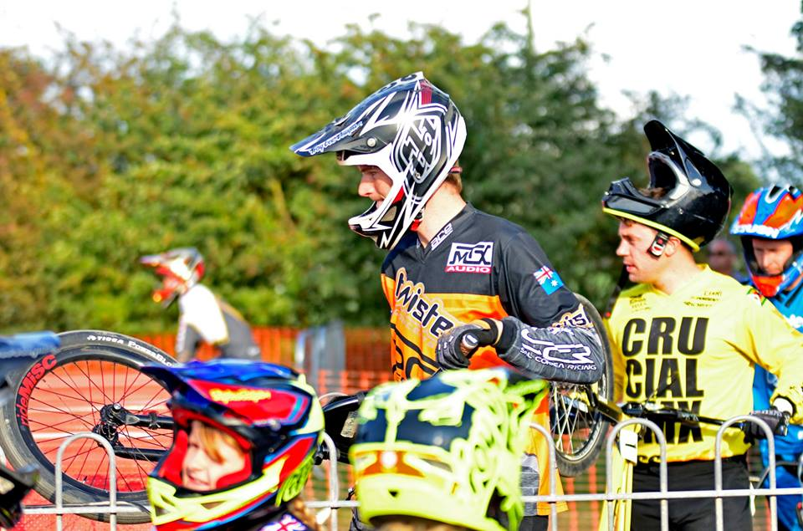

Rich Ayles, Cruiser & Masters.

Richard was looking forward to racing a new track, but not looking forward to the forecast weather. He rocked up on Saturday morning and with very little practice quickly found his preferred lines on the track. He thought the layout seemed like Telford, with a first straight that suits his style of riding.

Practice was going great until a big OTB, thankfully he sustained only superficial wounds and was good to go! Rich was racing both bikes on the Saturday, and due to the low numbers in 30-39 cruiser they were mixed with a pretty stacked 17-29 class. Racing was going well and 3 good moto results, topped with a 3rd moto win put him into the semi-finals. Another good lap in the semi put him into the final and he ended the day with a 7th, which he was pretty pleased with given the strength of the group.

On the 20” his racing was consistent, and he ended the day with a 4th place in a tough group which seems to get harder as the rounds go on.

On the Sunday Rich was only racing the one bike, which was a relief as his legs were feeling pretty tired from the previous day. The weather was not looking good either, so in probably the worse conditions he’d ever raced, Rich ended the day with 3rd place and strangely he enjoyed the challenging conditions. Rich said ‘I’m looking forward to finishing the season off at one of my favourite tracks in Leicester. Bring it on!’

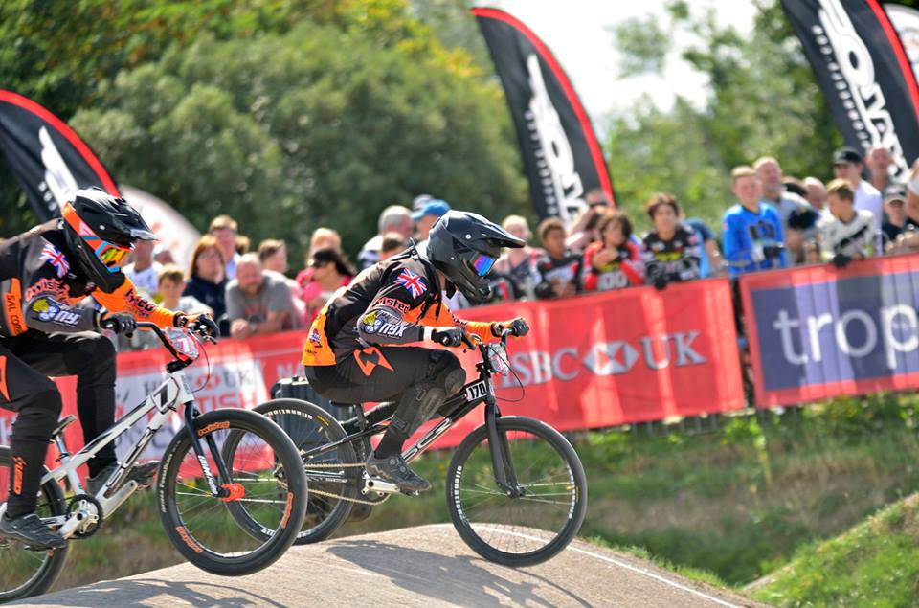

Miles Kirby, Vets.

Lord Miles had a superb regional at Gosport in the build up to the event, getting a 2nd in combined 30+ (Vets and Masters) and he was really looking forward to trying to turn his luck around after crashing or being put off the track quite a bit in this year’s nationals and messing up more than his fair share of semi- finals.

Saturday’s motos went well, Vets is a super evenly matched class, full of riders of a very similar standard and speed, so things are always very tough. He was feeling good, but there was that familiar feeling of deja-vu, the semi didn’t go to plan and Miles had to settle for the B final. He led the B out, but coming from an outside gate he couldn’t get across quick enough on the big wide first straight and a couple riders got into the berm under him. Miles battled hard but just couldn’t back get in front no matter what he tried and crossed the line still in 3rd, but it was super close all the way round.

Sunday, Miles had two really hard draws in the motos and managed to keep a couple of riders behind even though he was caught in traffic, enough to get through to the semis, but not enough for an inside gate selection. In Sunday’s semi-final he was in another 3 way battle for the 4th place all the way round, coming out of the first turn he managed to get a glimpse of the 4th place slot, but couldn’t hold it, he got another shot out of the final corner too slipping up the inside from a high low, but the rider on the outside bounced the racer taking the middle line into Miles, stopping him more or less dead, so it was a B final for the second day running. The Lord didn’t make any mistakes this time, leading out from the front and putting down two very fast straights to pull clear, then he carefully rode the second two, making sure he made no mistakes with two of his closest competitors breathing down his neck, taking a commanding victory.

Miles is hoping to turn his semi-final block around at Leister for the final two rounds, on a track that should suit his fearless cornering and powerful technique. Miles was especially impressed with his new Flow Vision goggles, they didn’t steam up at all, gave him great vision and sat comfortably in his helmet, giving him a clear view of the race in tough conditions, he also loved his Twisted Concepts disc brake system, giving him complete control and confidence in his bike in the torrential rain.

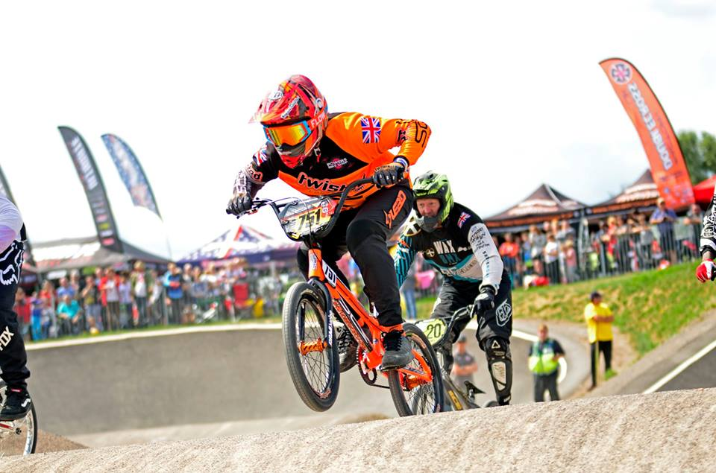

Myles Gault, Cruiser 45+

The unicorn pilot wasn’t really hoping for much at Gosport, it’s not a track he’s fond of, even though it has a brilliant gate and a power first straight. Saturday, moto one, Myles got a pretty good gate and was mid pack when all hell broke loose at the start of the third straight, he narrowly avoided the pile up and found himself battling for 3rd place, with a hard but fair berm move he secured the position. Moto 2 didn't go well, after winding himself up and blowing his gate completely. Moto 3 saw some great battles but not good enough to make the cut to the knockout stage, so time for an early beer.

On Sunday the track and bad weather were not going to suit his style. Too many previous injuries saw him seizing up in the cold and damp, and in his words ‘riding like a corpse with rigor mortis’. He said ‘at least my appearance was on point thanks to the Flow Vision goggles’. Myles is looking forward to Leicester and a track he thinks will suit his style.

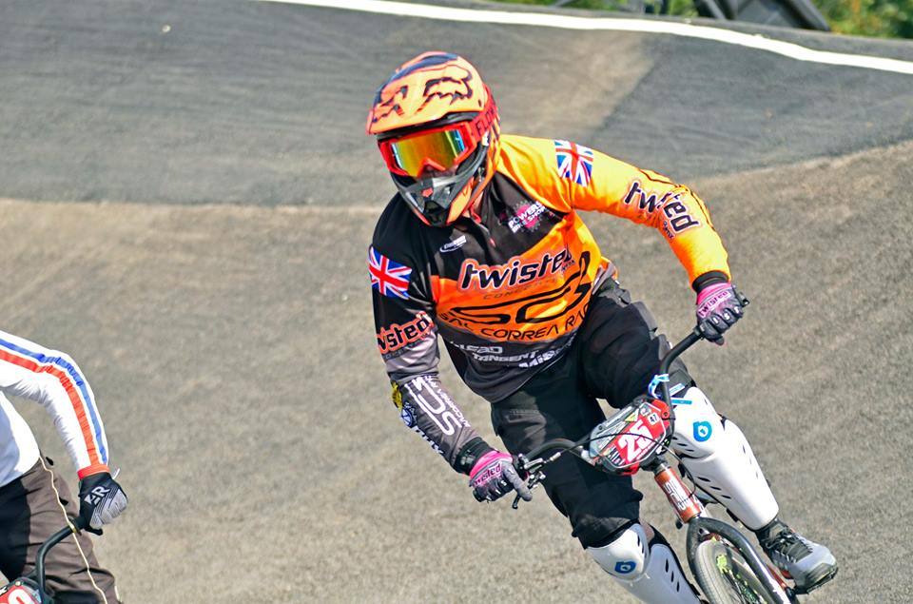

Please pop by to see us at Leicester National, we’ll be more than happy to show you what we believe are the best factory race bikes there are. We’ll have Twisted signature FIST gloves for sale, as well as the super cool looking range of Flow Vision goggles. Our signature ‘3g weave’ carbon rims will be on display and ready to buy, plus all the rest of our hardware on show.

After the torrential rain at Gosport maybe you’re now ready to go down the disc route, which we have been at the forefront of in the UK and we’ll be happy to discuss our bracket options and advise you on which Onyx to get (and remember if you get your Onyx hubs from us laser etching is complementary). We are also the European service and warranty centre for Onyx, we only use Onyx ceramic bearings and the same Teflon grease used in the Onyx factory, so your hubs will literally come back like new. Remember if you order hubs from us we can do them in nearly any conceivable colour combination and custom laser etching is complementary.

We now have SCR frames in all sizes, disc specific or V brake, and if you’re looking for a special colour and decal combination we can sort that out, no problem at all, with our custom painters and special relationship with ENV Graphics.

We would like to thank our sponsors and team partners Cranks Bros, Powers Bikes Shop, Lead Racewear, Custom Racing, Tangent and ODI Grips, FIST gloves and Flow Vision goggles.

Words: Lord Miles Kirby
Photos: BMX Widow

